# laboratoriuli samuSao 2

***davaleba 1***

**1)** axali furclis **A1:A6** ujrebSi SeitaneT sxvadasxva tipis monacemi: **A1-**Si teqsti SriftiT **Arial,**  **A2-**Si mravalniSna mTeli ricxvi, **A3-**Si uaryofiTi ricxvi, **A4-**sa da **A5-**Siwiladis Semcveli ricxvebi, **A6-**Si TariRi (nax. 2.1);

**2)** **B1:B6** ujrebSi miiReT **A1:A6** ujrebis SigTavsis asli: moniSneT **A1:A6** da SeasruleT brZaneba **Copy,** SemdegmoniSneT **B1** da SeasruleT **Paste;**

**3)** moniSneT **B1** da Setanili teqstisaTvis airCieT **Acad Nusx** Srifti da centris mimarT sworeba. **Format Cells-Number-Number** dialogis fanjridan airCieT monacemebisTvis 2.1 nax.-is Sesabamisi formatebi: moniSneT **B2** da CarTeT **Use 1000 Separator (,)** alami - mravalniSna ricxvi gamoCndeba mZimiT gamoyofil cifrebis sameulebis saxiT;

**4)** moniSneT **B3** da igive dialogis fanjridan uaryofiTi ricxvisaTvis **Negative Numbers** velSiairCieT wiTeli feris formati**;**

**5)** moniSneT **B4** da **Format Cells-Number-Currency** dialogis fanjaraSi **Symbol** velSi airCieT valutis niSani. analogiurad sxva formati airCieT **B5-**sTvis;

**6)** moniSneT **B6** da **Format Cells- Number- Date** fanjaraSi airCieT TariRis formati:

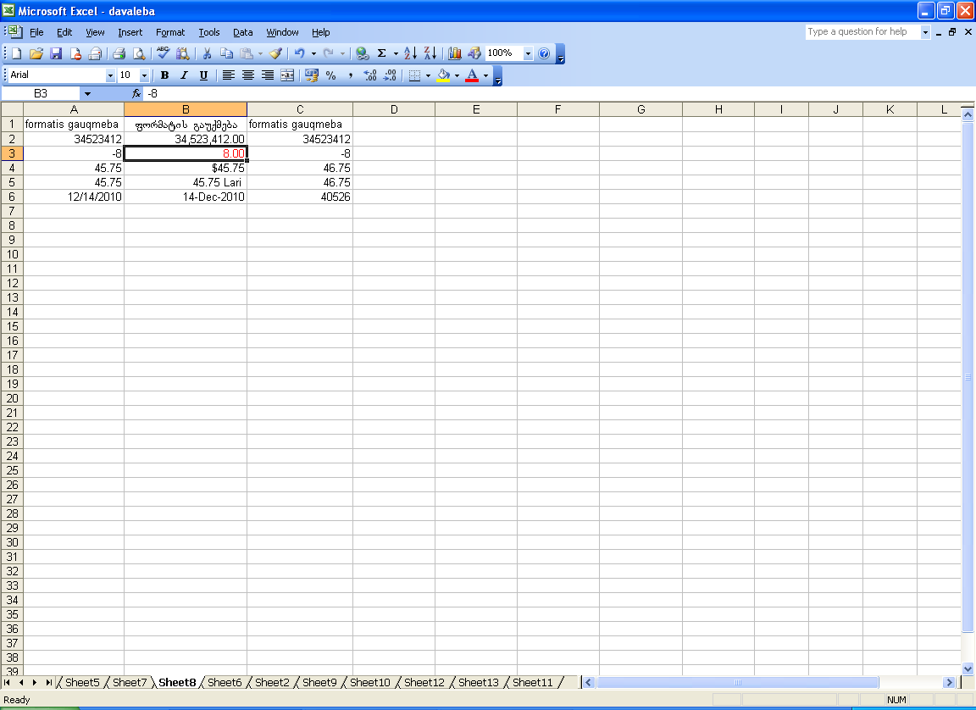

nax. 2.1

***davaleba 2***

**1)**  isargebleT **1**-li davalebis cxriliT (nax. 2.1) da miiReT **B1:B6** ujrebis SigTavsis asli **C1:C6** ujrebSi: moniSneT **B1:B6** da SeasruleT brZaneba **Copy,** SemdegmoniSneT **C1** da SeasruleT **Paste;**

**2)** moniSneT **C1:C6** ujrebi da **Home- Editing-Clear Formats** punqtiT gaauqmeT miniWebuli formatebi;

**3)** Sedegad, teqstSi **Acad Nusx** Srifti Seicvala **Arial-**iT da gauqmda centris mimarT sworeba; **B2-**Si gauqmda mravalniSna ricxvis formati, **B3-**Sigauqmda uaryofiTi ricxvis wiTeli formati; **D6, D7-**Si gauqmda valutis formati, **A8-**Si TariRis nacvlad Caiwera ricxvi **40526**, romelic Seesabameba dReTa raodenobas, aTvlils 1900 wlis 01.01-dan miTiTebul TariRamde.

***davaleba 3***

**1)** axali furclis **A1** ujraSi (nax. 2.3) SeitaneT Sereuli tipis monacemi (teqsti, ricxvi), daafiqsireT **Enter** RilakiT da ujris markeriT gadaitaneT **B1:D1** ujraTa diapazonSi. daakvirdiT Sedegs. msgavsi moqmedeba SeasruleT meore striqonze;

**2) A3-**Si SeitaneT ricxvi **1**, daafiqsireT. **Home- Editing –Fill- Series** dialogis fanjaraze arsebul **Series in** ganyofilebaSi CarTeT Rilaki **Columns. Step value** (cvlilebis biji) da **Stop value** (saboloo mniSvneloba) velebSi SeitaneT, Sesabamisad, ricxvebi **1** da **6**. **OK** Rilakze daWeriT sveti Seivseba ricxvTa TanamimdevrobiT;

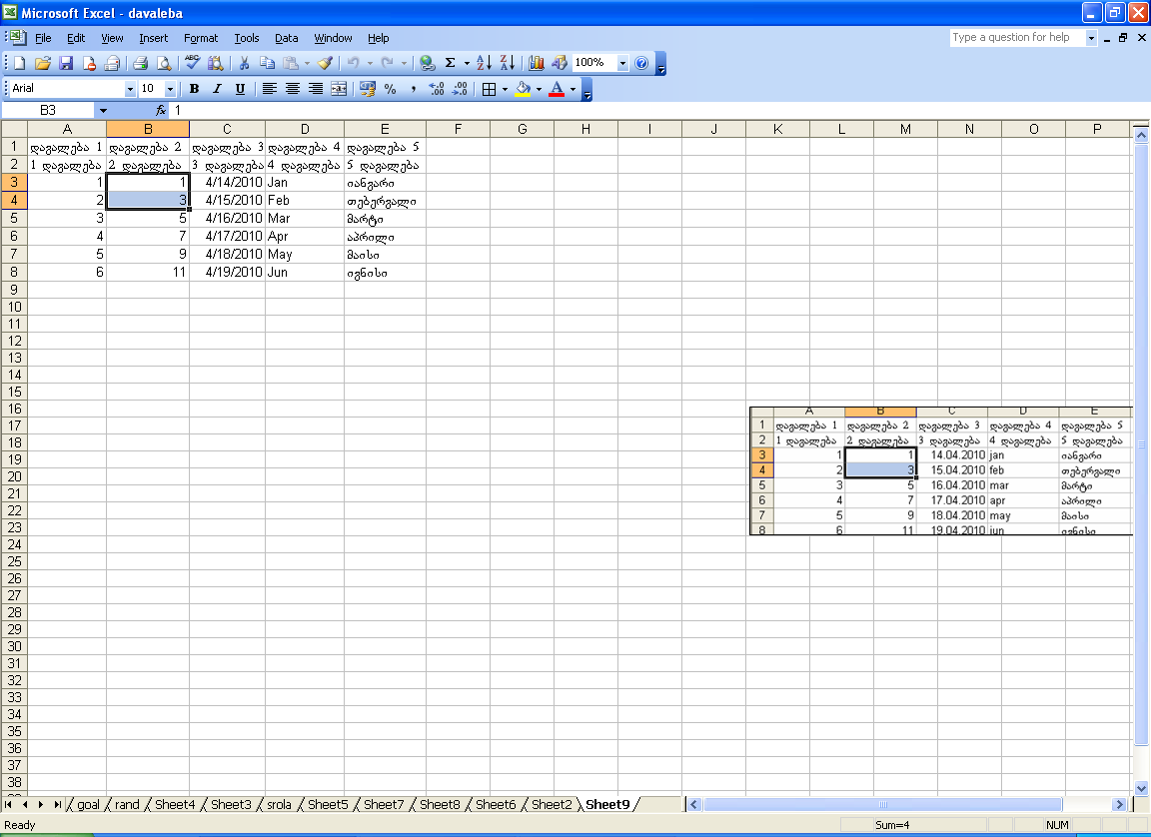

nax. 2.3

**3) B3, B4** ujrebSi SeitaneT ricxvebi **1** da **3**, moniSneT orive da markeriT gaavrceleT momdevno ujrebSi **B8** ujris CaTvliT. miiReba ricxvTa Tanamimdevroba bijiT **2**;

**4) C3** ujraSi SeitaneT TariRi, ujris markeriT gaavrceleT qveda ujrebze. miiReba TariRTa mimdevroba dReebis cvlilebiT;

**5) D3** ujraSi SeitaneT **Jan,** ujris markeriT gaavrceleT qveda ujrebze. miiReba inglisurenovani Tveebis CamonaTvali**;**

**6)** Tveebis qarTulad (an nebismieri sxva Semcvelobis siis) gamotanis mizniT **K1:K12** ujrebSi SeitaneT Tveebis CamonaTvali qarTuli Sriftis gamoyenebiT. moniSneT sia da SeasruleT **Office Button-Excel Options-Popular-Custom Lists** brZaneba**.** moniSnuli aris misamarTi aisaxeba velSi. **Import** Rilakze TiTis daWeriT sia moTavsdeba **List entries** velSi, ris Semdeg daaWireT **Add, OK**. ujraSi **E3** SeitaneT qarTuli SriftiT sityva “ianvari” da markeriT gaavrceleT **E12** ujramde, miiRebT qarTulenovani Tveebis CamonaTvals.

***davaleba* *4***

SeqmeniT cxrili, romelic asaxavs fexburTis gundebis saturniro mdgomareobas. mocemulia TamaSebis raodenoba, mogeba, fre, wageba, burTebis Sefardeba, qula.

**1)** SeqmeniT cxrilis saTave. moniSneT **A1:R1**, gaaerTianeT da SeitaneT teqsti naxatis mixedviT (nax. 2.4). ujrebis gasaerTianemlad gamoiyeneT **Merge & Center** Rilaki;

**2)** moniSneT **I2:M2,** gaaerTianeT da SeavseT monacemiT. igive wesiT SeavseT **N2:R2;**

**3) Ctrl** klaviSis gamoyenebiT erToblivad moniSneT **G3:G6, L3:L6** da **Q3:Q6** diapazonebi. **Format-Cells-Number-Text** meSveobiTmianiWeT maT teqstis formati da SeavseT monacemebiT;

**4)** moniSneT **A1:R2** ujrebi da **Fill Color** Rilakis gamoyenebiT gaukeTeT nacrisferi foni. moniSneT mTeli cxrili da gaukeTeT CarCo. carieli ujrebi SeavseT monacemebiT:

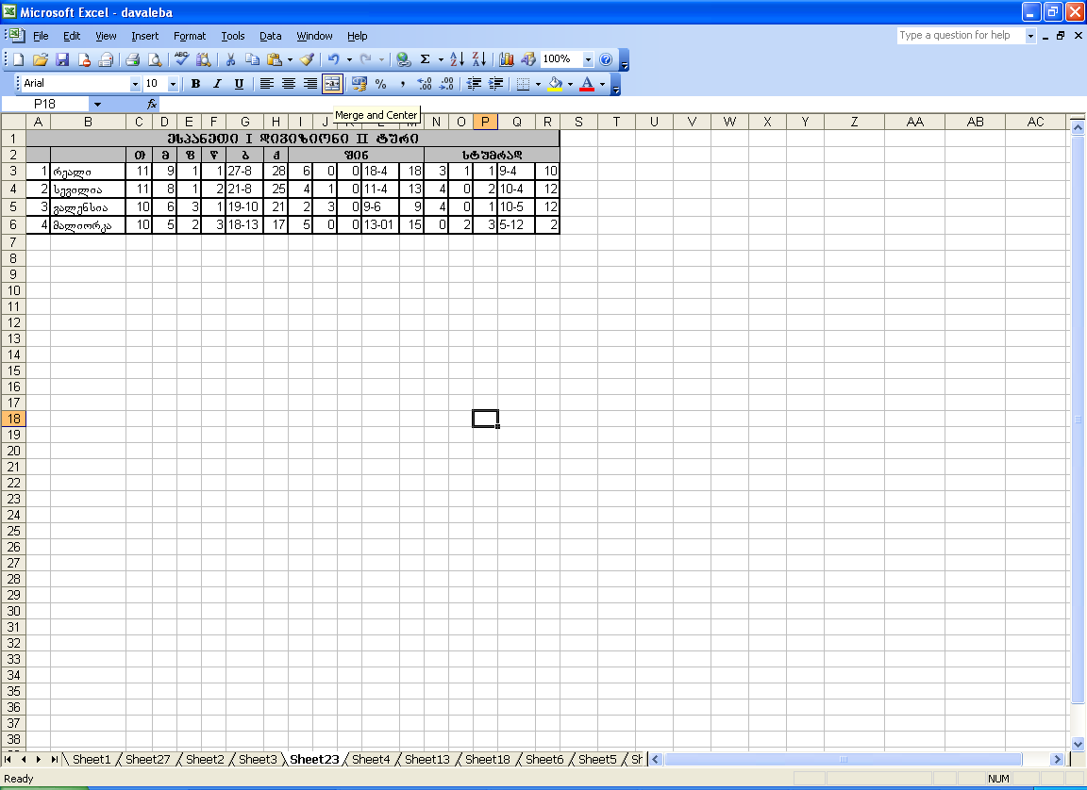

nax. 2.4